BSDS FINAL PROJECT
Requirements Specification

Multimodal AI for Early Detection and Monitoring of Eye Diseases in South Asian Populations



Project Advisor

Ms Sumra Fayyaz

Presented by:
Group ID: F25DS010

Student Reg# Student Name
L1F22BSDS0021 Muhammad Khallad Ahmad
L1F22BSDS0033 Fazal Elahi
L1F22BSDS0020 Muhammad Azhar Sajjad

Faculty of Information Technology & Computer Science
University of Central Punjab

Software Requirements Specification

Version 1

Multimodal AI for early Detection and Monitoring of Eye Diseases in South Asian Populations

Advisor: Ms Sumra Fayyaz

Group F25DS010
Member Name | Primary Responsibility
M. Khallad Ahmad | System Architecture, AI, Machine Learning
Fazal Elahi | App Development
M. Azhar Sajjad | UX, UI and Documentation

Table of Contents
Table of Contents i
Revision History ii
Previous Phases Feedback ii
Abstract 1
1. Introduction and Background 2
1.1 Product (Problem Statement) 2
1.2 Background 2
1.3 Scope 2
1.4 Objective(s)/Aim(s)/Target(s) 3
1.5 Challenges 3
1.6 Learning Outcomes 3
1.7 Nature of End Product 4
1.8 Completeness Criteria: 4
The project will be considered complete when 4
1.9 Business Goals 4
1.10 Related Work/ Literature Survey/ Literature Review 5
Proposed Solution 6
1.11 Document Conventions 6
2. Overall Description 7
2.1 Product Features 7
2.2 User Classes and Characteristics 7
2.3 Operating Environment 8
2.4 Design and Implementation Constraints 8
2.5 Assumptions and Dependencies 9
3. Functional Requirements 10
Use-Case Diagram 10
Below is the high-level use-case diagram showing interactions between the system and external actors: 10
3.1 Capture Eye Image 10
3.2 Predict Eye Disease 12
3.3 View Past Predictions 13
3.4 Tele opthamology 14
3.5 Generate Risk Report 15
3.6 Notification for Follow-up 16
3.7 Payment Method 17
3.7 Requirements Analysis and Modeling 21
3.7.1 Sequence Diagram: 21
4. Nonfunctional Requirements 24
4.1 Performance Requirements 24
4.2 Safety Requirements 24
4.3 Security Requirements 24
4.4 Additional Software Quality Attributes 25
5. Other Requirements 25
6. Revised Project Plan 26
7. References 26
Appendix A: Glossary 28
Appendix B: IV & V Report 30

Revision History
Name | Date | Reason For Changes | Version

Previous Phases Feedback

Idea Defence Feedback (Screenshot)

Abstract
This project develops a multimodal Artificial Intelligence (AI) system designed to address the high prevalence of undiagnosed and preventable eye diseases in South Asian populations. The core problem lies in the limited availability of reliable, early-stage screening tools that can perform accurately across diverse demographic and anatomical variations unique to this region. Early detection is essential for preventing irreversible blindness, yet current diagnostic methods are inaccessible, resource-intensive, and often depend on Western-trained models that do not generalize well to South Asian patients.
To solve this problem, the project integrates multiple data modalities fundus images, OCT scans, and patient metadata such as age, gender, blood pressure, and sugar levels into a unified predictive framework. Using transfer learning with advanced Vision Transformer architectures (ViT and Swin Transformers), the system leverages deep learning, medical imaging analysis, multimodal data fusion, and explainable AI techniques to achieve high diagnostic performance. Offline deployment, tele-ophthalmology support, self-screening guidance, and progression monitoring further strengthen its practical value in underserved regions.
The expected outcomes include achieving over high accuracy in detecting major eye diseases such as diabetic retinopathy, glaucoma, cataracts, macular degeneration, and retinopathy of prematurity. The project aims to deliver a culturally adapted, interpretable, and scalable AI-driven screening tool capable of improving early diagnosis, reducing patient risk, and bridging the eye-care accessibility gap across South Asia.

Introduction and Background
This project presents a mobile-based multimodal Artificial Intelligence (AI) application designed for early detection, monitoring, and personalized management of major eye diseases affecting South Asian populations. In many areas of South Asia, individuals lack access to ophthalmologists, specialized imaging devices, and affordable diagnostic services. As a result, preventable eye conditions often progress unnoticed until irreversible damage occurs. A mobile-based AI solution can bridge this gap by enabling users, community health workers, and primary care providers to perform rapid screening without requiring advanced medical infrastructure.
The proposed mobile application allows users to capture eye images using the device’s built-in camera, upload fundus or OCT images (if available), and provide basic health metadata such as age, gender, blood pressure, and sugar levels. A multimodal AI model—leveraging Vision Transformer architectures—analyzes these inputs to detect diseases such as diabetic retinopathy, glaucoma, cataracts, macular degeneration, and retinopathy of prematurity. The system is designed for offline deployment, interpretability, and usability, making it suitable for rural and underserved regions.

Product (Problem Statement)
The product is a mobile application that enables users to capture eye images using their smartphone camera and receive instant AI-based predictions about potential eye diseases. The system supports analysis of camera-captured images, uploaded fundus/OCT images, and patient metadata. It addresses the problem of limited access to early, reliable, and population-specific eye screening tools in South Asia.

Background
Traditional eye screening relies on specialized equipment operated by trained professionals, which is not feasible in many South Asian communities. Mobile health (mHealth) technologies and AI-based image classification offer an opportunity to democratize early detection. While several AI ophthalmology tools exist globally, most require high-quality fundus cameras or cloud connectivity. Moreover, models trained on Western datasets may not perform well on South Asian populations. This project focuses on developing a mobile, offline-capable, multimodal AI solution adapted specifically to regional demographics, device limitations, and real-world screening scenarios.

Scope
This SRS covers:
- Development of a mobile application supporting camera-based eye image capture.
- Integration of multimodal AI (camera images + fundus/OCT images + metadata).
- Local (offline) inference on-device or on a lightweight local server.
- Disease detection, severity estimation, and risk scoring.
- Explainability features for clinical interpretability.
- User-friendly interface for non-specialists and rural health workers.
- Optional tele-ophthalmology module for remote specialist review.
- Out of scope: clinical decision-making, treatment planning, hospital information system integration, and hardware device manufacturing.

Objective(s)/Aim(s)/Target(s)
- Enable users to capture eye images via smartphone camera for screening.
- Achieve high accuracy in detecting major eye diseases using multimodal AI.
- Ensure the application functions offline for low-connectivity regions.
- Provide explainable AI outputs such as heatmaps and attention maps.
- Support uploading of fundus/OCT images when available.
- Offer intuitive UI/UX suitable for health workers and general public.
- Track disease progression through periodic image captures.
- Enable optional remote consultations through telemedicine features.

Challenges
- Limited availability of high-quality South Asian retinal datasets.
- Variations in imaging devices and patient demographics.
- Ensuring accurate multimodal fusion of image and metadata inputs.
- Maintaining accuracy in offline deployment with limited computational resources.
- Achieving clinical trust through interpretability and transparency.
- Addressing potential biases arising from imbalanced datasets.
- Ensuring secure handling of sensitive patient data.

Learning Outcomes
- Deep learning architectures, particularly Vision Transformers.
- Multimodal data fusion and medical imaging pipelines.
- Explainable AI (XAI) techniques.
- Data preprocessing for fundus and OCT datasets.
- Model optimization and evaluation for healthcare applications.
- Software engineering principles for medical diagnostic tools.
- Ethical and privacy considerations in AI-driven healthcare.

Nature of End Product
- The final deliverable will be a functional mobile application with:
- Image capture capability using the device camera.
- Upload options for fundus/OCT images.
- On-device AI-based disease prediction and severity grading.
- Explainability overlays (e.g., heatmaps).
- History tracking for disease progression.
- Option to share results with specialists via tele-ophthalmology.

Completeness Criteria:

The project will be considered complete when
- The mobile app successfully captures eye images and processes them.
- Multimodal AI model is integrated and achieves ≥85% test accuracy.
- Predictions are generated offline with reasonable inference time.
- Explainability features (visual heatmaps) are included.
- UI supports metadata input, history view, and result display.
- Basic telemedicine feature (export/share results) is implemented.
- Full documentation (SRS, design, testing report) is provided.

Business Goals
- Provide affordable, accessible screening to rural and low-income populations.
- Reduce the burden of preventable blindness through early detection.
- Offer a scalable solution suitable for NGOs, clinics, and public health programs.
- Support telemedicine adoption in underserved regions.
- Enable large-scale community screening using only smartphones.

Related Work/ Literature Survey/ Literature Review
EyeArt by Eyenuk
- Application Focus: Automated detection of diabetic retinopathy exclusively.
- Modality Access: Uses fundus images only.
- Deployment Access: Cloud-based, requires internet to process images.
- Limitations: Single disease focus; limited generalizability across populations.
Ogler EyeScan
- Application Focus: Detection of anterior segment eye diseases such as Arcus, Pterygium, and cataracts.
- Modality Access: Anterior eye images only; limited scope beyond cataracts.
- Deployment Access: Mobile iOS app; relies on internet access.
- Limitations: Narrow disease detection; does not combine multiple types of data.
e-Paarvai
- Application Focus: Cataract screening.
- Modality Access: Fundus imaging-based screening tool.
- Deployment Access: Android app; limited offline functionality.
- Limitations: No AI-based multimodal data analysis or personalized recommendations.
Sehat Kahani
- Application Focus: General telemedicine platform providing remote consultations.
- Deployment Access: Mobile platform for general healthcare teleconsultation.
- Limitations: Does not offer AI-based diagnostics for eye diseases; lacks dedicated AI diagnostics and offline capabilities.

Proposed Solution
- Combination of fundus and OCT images, along with structured patient metadata, for multimodal detection of five major eye diseases.
- Integration of explainable AI for transparency and interpretability of diagnostics.
- Offline deployment on mobile to support low connectivity zones.
- Tailored design for South Asian populations, considering anatomical and demographic differences.
- Helping patients take an active role with features like self-screening and personalized advice to improve access to eye care.

Document Conventions
- IEEE SRS formatting and numbering standards are followed.
- Bold headings denote major sections and subsections.
- Italicized text is used for explanatory notes and emphasis.
- Acronyms such as AI, OCT, and ViT are defined on first use and reused consistently.
- Standard technical terminology is maintained throughout.
.

Overall Description

Product Features
The mobile application provides the following high-level features:
- Image Capture & Upload: Users can capture eye images directly using the smartphone camera.
- Multimodal Prediction: AI model predicts major eye diseases using captured images and patient metadata.
- Risk Scores & Severity Grading: Provides disease probability and severity levels.
- Explainable AI Visualizations: Heatmaps and attention overlays for clinical interpretability.
- Offline Functionality: Core AI predictions work without internet access.
- Tele-Ophthalmology Support: Option to share results with remote specialists.
- Progress Monitoring: Tracks disease progression over time.
- User-Friendly Interface: Simplified workflow suitable for non-expert users.

User Classes and Characteristics
1. Clinical Ophthalmologist

- Regular users who will utilize all features of diagnostic, monitoring, and tele-ophthalmology.

- Usually have some level of advanced medical training and moderate to high level of technical skill.

- Require access to high security settings to access sensitive patient information and clinical functions.

2. Patients

- Use the system on an intermittent basis for self screening, tracking their ongoing condition, and accessing reminders.

- Access will be restricted to their own information and feedback relevant to their situation.

3. System Administrators and IT Personnel

- Interacts periodically to manage user accounts, maintain system functionality, and protect security.

- Have high level of technical, functional knowledge and a high level of access.

Less Important to Satisfy

- General Public without Eye Conditions: They do not need to access the system.

- Non-clinical staff: For instance, administrative personnel who are not related to ophthalmology-do not need access to clinical data or AI diagnostics.

- Specialists not involved in eye care: Other medical specialists, like cardiologists and dermatologists, would not interact with the system.

- External Researchers: Unless explicitly granted, access can be controlled and is not provided by default users.

Operating Environment
- Hardware: Android/iOS smartphones with at least 3GB RAM, 2MP+ camera.
- Operating System: Android 9+ or iOS 10+.
- Software Dependencies: TensorFlow Lite / PyTorch Mobile for AI inference, SQLite/Cloud backend for data storage.
- Connectivity: Internet required for tele-ophthalmology, optional for offline predictions.
- Coexisting Applications: Should coexist peacefully with camera and gallery apps.

Design and Implementation Constraints
- Hardware Limitations: The application must operate efficiently on smartphones with limited CPU, GPU, memory, and storage. The AI model should be optimized for fast inference without draining battery.
- Offline Functionality: Core disease prediction must work without internet connectivity, which constrains model size and complexity. Techniques such as quantization and pruning may be required.
- Regulatory Compliance: The system must adhere to local healthcare regulations and international data privacy standards (e.g., GDPR, HIPAA). Patient data must be securely encrypted at rest and in transit.
- Software Dependencies: The AI model relies on mobile-compatible frameworks such as TensorFlow Lite or PyTorch Mobile. Backend components for tele-ophthalmology or cloud storage must be compatible and secure.
- User Interface & Accessibility: The interface should remain intuitive, responsive, and accessible across various screen sizes and for users with limited technical skills.
- Data Constraints: Accuracy depends on representative South Asian datasets; limited or biased data may affect performance.
This ensures that the application is technically feasible, secure, and user-friendly while complying with regulatory standards and device limitations.

Assumptions and Dependencies
- User Device Capability: It is assumed that users will have smartphones with functional cameras capable of capturing clear eye images.
- Accurate Metadata Input: Users are expected to provide correct information such as age, gender, blood pressure, and sugar levels.
- Model Availability: The AI model is pre-trained on relevant South Asian datasets and packaged for mobile deployment.
- Internet Connectivity: Internet access is required for optional tele-ophthalmology consultation and cloud-based data backup, but core predictions work offline.
- Third-Party Libraries: The application depends on frameworks such as TensorFlow Lite or PyTorch Mobile, which are assumed to work reliably on supported devices.
- User Compliance: Users will follow app instructions for image capture and input entry, which is critical for accurate predictions.
- Environmental Conditions: Adequate lighting and minimal camera shake are assumed during image capture to maintain prediction accuracy.

Functional Requirements

Use-Case Diagram

Below is the high-level use-case diagram showing interactions between the system and external actors:
Actors:
- Patient / General User: Captures eye images and views predictions.
- Clinician Monitors patients, and views risk reports.
- System / AI Model: Performs image analysis, prediction, and storage of results.

Capture Eye Image
Identifier |  | UC-1
Purpose |  | Enable the user to capture an image of their eye for disease analysis.
Priority |  | High
Pre-conditions |  | User has a registered account and granted camera access.
Post-conditions |  | Eye image is successfully captured and ready for analysis.
Typical Course of Action
S# | Actor Action |  | System Response
1 | Opens the mobile app |  | Displays camera interface for eye capture
2 | Positions eye and clicks capture |  | Captures image and confirms successful capture
3 | Confirms image |  | Sends for AI analysis
Alternate Course of Action
S# | Actor Action |  | System Response
1 | Image is blurry |  | System prompts user to retake image
2 | Camera access denied |  | System shows permission request message
Table 1: UC-1

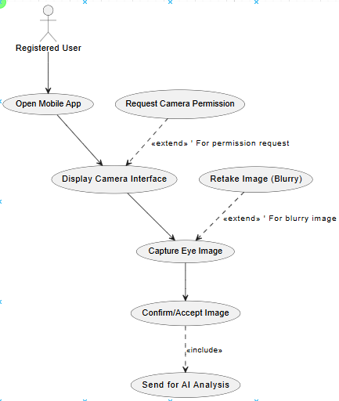

Predict Eye Disease
Identifier |  | UC-2
Purpose |  | Analyze the captured eye image and predict potential eye diseases.
Priority |  | High
Pre-conditions |  | Eye image has been successfully captured.
Post-conditions |  | Prediction results and risk scores are generated and stored.
Typical Course of Action
S# | Actor Action |  | System Response
1 | Requests prediction |  | System sends image to AI model
2 | Waits for result |  | AI model analyzes and returns prediction
3 | Views result |  | System displays predicted disease and risk score
Alternate Course of Action
S# | Actor Action |  | System Response
1 | AI model fails to predict |  | System notifies user of failure and retries
2 | User wants second opinion |  | System allows image export for external review
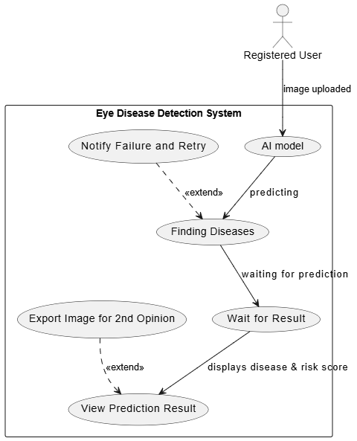
Table 2: UC-2

View Past Predictions
Identifier |  | UC-3
Purpose |  | Allow users to view previous predictions and monitor disease progression.
Priority |  | Medium
Pre-conditions |  | User has prior prediction results stored in the system.
Post-conditions |  | Past predictions and risk history are displayed.
Typical Course of Action
S# | Actor Action |  | System Response
1 | Selects “History” |  | System retrieves stored prediction results
2 | Scrolls through history |  | System displays date, image, disease, risk score
Alternate Course of Action
S# | Actor Action |  | System Response
1 | No history available |  | System displays message: “No past predictions available”
Table 3: UC-3

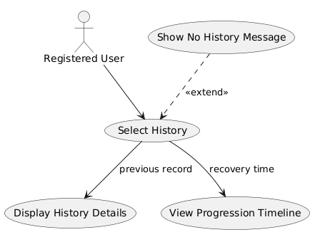


Tele opthamology
Identifier |  | UC-4
Purpose |  | Enable remote eye disease consultation between patients and ophthalmologists.
Priority |  | High
Pre-conditions |  | - Eye images and medical data have been uploaded.  - Ophthalmologist is available.
Post-conditions |  | Diagnosis and recommendations are submitted and shared with the patient.
Typical Course of Action
S# | Actor Action |  | System Response
1 | Patient requests tele-ophthalmology consultation. |  | System authenticates patient and grants access.
2 | Patient sends eye images and medical data to doctor. |  | System for to pay to visit a doctor.
3 | Ophthalmologist submits diagnosis and recommendations. |  | User is send notification of a meeting with doctor.
Alternate Course of Action
S# | Actor Action |  | System Response
1 | Network failure during  Connection with doctor |  | System retries connection.
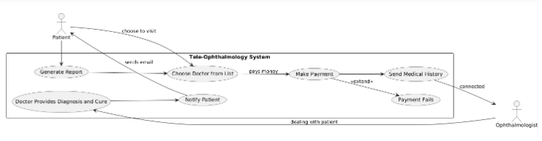
Table 4: UC-4

Generate Risk Report

Identifier |  | UC-5
Purpose |  | Generate a comprehensive risk report for the user or patient.
Priority |  | Medium
Pre-conditions |  | Prediction results exist for the selected user/patient.
Post-conditions |  | Risk report is displayed or exported successfully.
Typical Course of Action
S# | Actor Action |  | System Response
1 | Selects “Generate Report” |  | System retrieves prediction results
2 | Requests report |  | System generates detailed report with charts
3 | Views/downloads report |  | Report displayed and optionally exported as PNG or JPEG
Alternate Course of Action
S# | Actor Action |  | System Response
1 | No prediction exists |  | System prompts: “No data available for report generation”
Table 5: UC-5
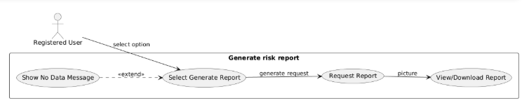

Notification for Follow-up
Identifier |  | UC-6
Purpose |  | Notify users about follow-up actions or upcoming check-ups based on risk score.
Priority |  | Medium
Pre-conditions |  | Prediction results have been generated.
Post-conditions |  | User receives notification for follow-up.
Typical Course of Action
S# | Actor Action |  | System Response
1 | User enables notifications |  | System schedules alerts based on risk score
2 | Follow-up due |  | System sends push notification and/or email
Alternate Course of Action
S# | Actor Action |  | System Response
1 | User disables notifications |  | System does not send alerts
Table 6: UC-6

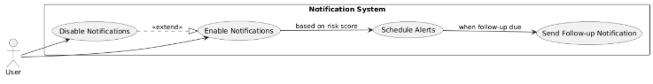

3.7 Payment Method
Identifier |  | UC-7
Purpose |  | Process payment securely using Stripe payment method.
Priority |  | High
Pre-conditions |  | User has selected a service or product and proceeds to payment.
Post-conditions |  | Payment is successfully processed or an error is returned.
Typical Course of Action
S# | Actor Action |  | System Response
1 | User selects Stripe as payment method |  | User enters payment details
2 |  |  | User submits payment
3 |  |  | System confirms payment status
Alternate Course of Action
S# | Actor Action |  | System Response
1 |  |  | Payment declined by Stripe

Table 7: UC-7

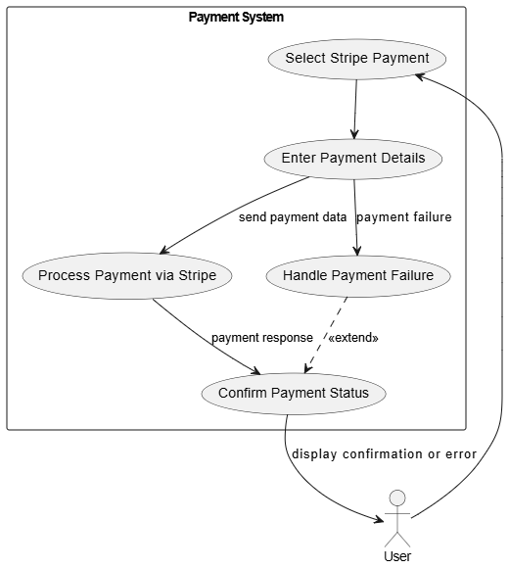

3.8 Registration of Doctor
Identifier |  | UC-8
Purpose |  | Ensure only legitimate PMDC-verified doctors can register and access the tele-ophthalmology platform.
Priority |  | High
Pre-conditions |  | Doctor provides PMDC license number and required personal information.  PMDC verification service (API or scraper) is accessible.
Post-conditions |  | Doctor is either successfully registered and verified OR rejected due to invalid PMDC status.  Verified doctor profile is stored in the system database.
Typical Course of Action
S# | Actor Action |  | System Response
1 | Doctor selects "Register as Doctor" |  | System displays registration form.
2 | Doctor enters required information. |  | System validates input fields.
3 | Doctor submits the form |  | System triggers automated PMDC verification process.
 |  |  | System confirms it results provided by doctor through pmdc website.
 |  |  | System compares PMDC data with provided doctor info.
Alternate Course of Action
S# | Actor Action |  | System Response
1 |  |  | PMDC website unreachable or scraper fails, system asks doctor to retry later.
2 | Doctor enters incorrect PMDC number |  | System displays Invalid PMDC License Number error.
3 | PMDC status is inactive/expired |  | System rejects registration and shows Your PMDC license is not active.

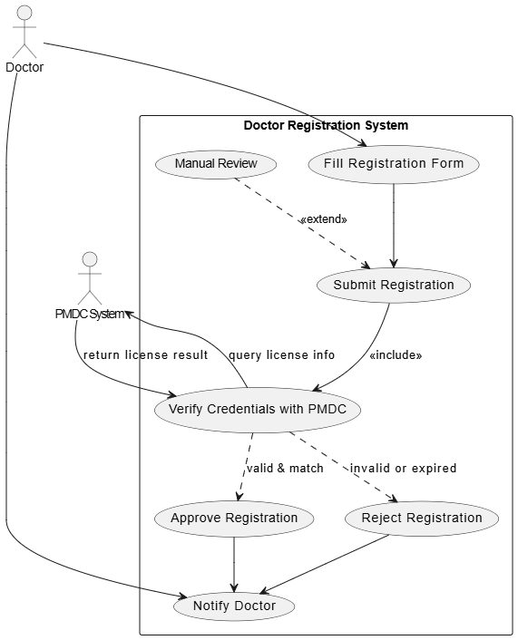

Requirements Analysis and Modeling

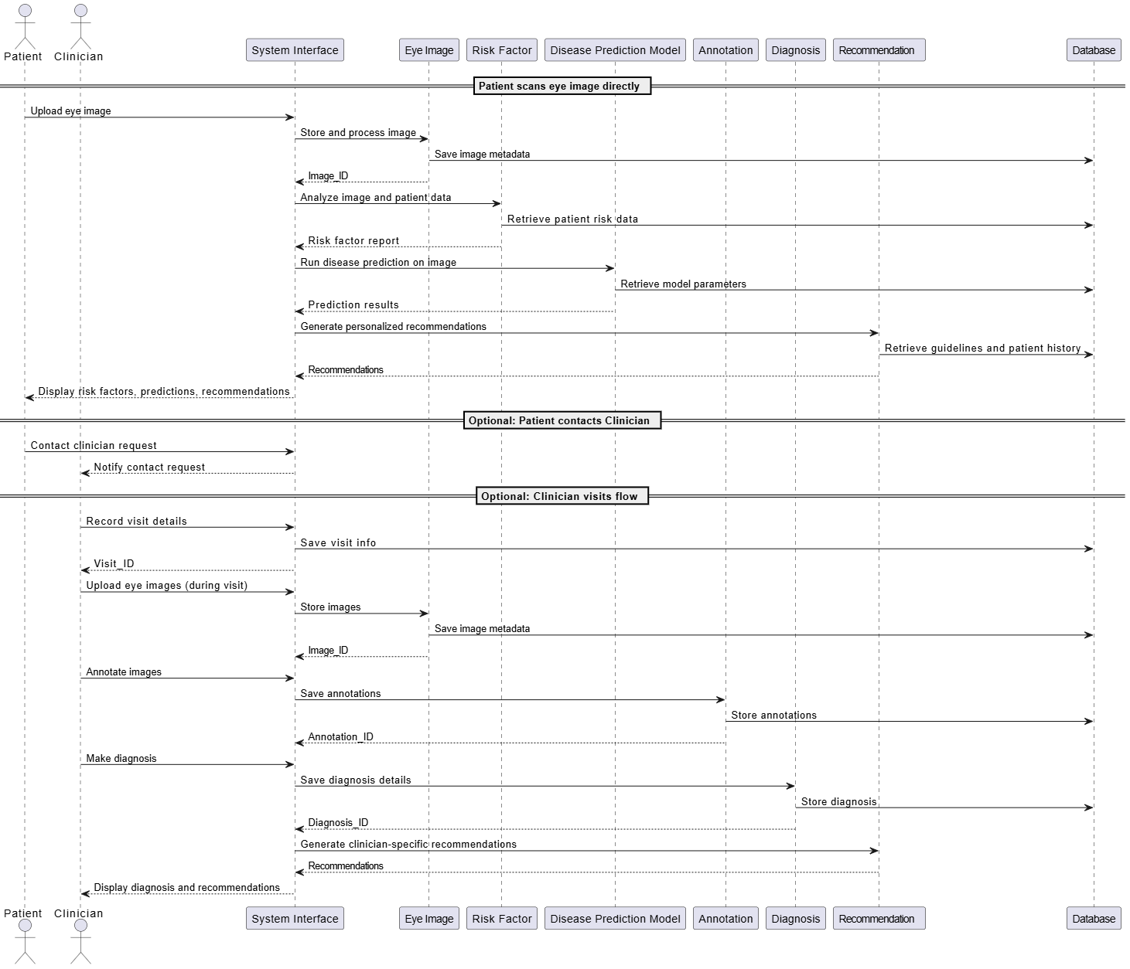
Sequence Diagram:

3.8.2 Class Diagram

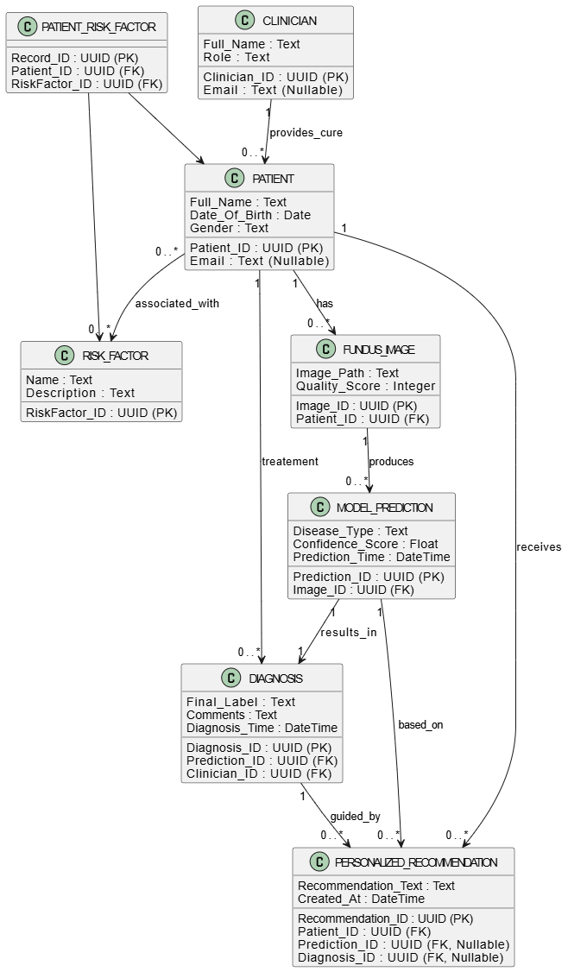

3.8.3 ERD

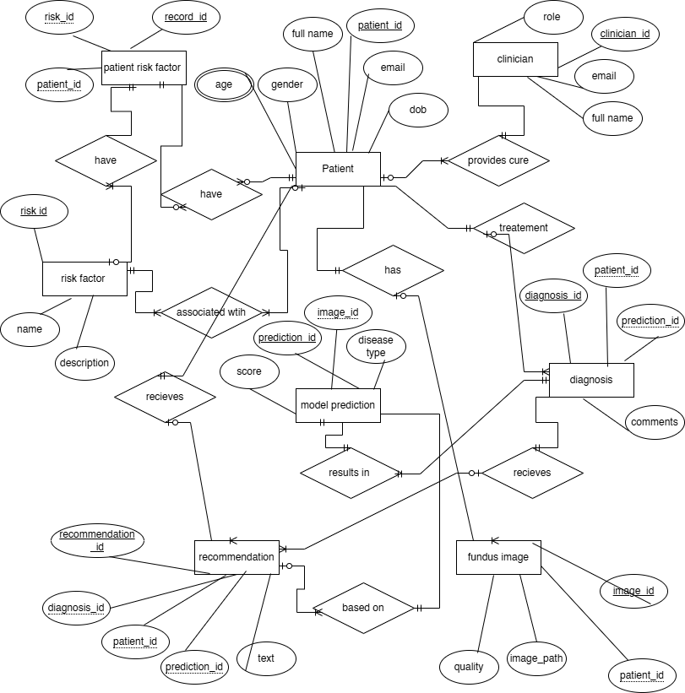

Nonfunctional Requirements

Performance Requirements
- Response Time: The system must provide predictions for uploaded eye images within 3–5 seconds under standard mobile network conditions (4G/5G).
- Throughput: The mobile application should handle at least 500 simultaneous users without degradation in response time.
- Accuracy: The AI model must achieve a minimum diagnostic accuracy of 85% for the detection of common eye diseases (e.g., diabetic retinopathy, glaucoma, macular degeneration) in the South Asian population.
- Scalability: The system architecture must allow easy scaling to accommodate an increasing number of users and image uploads without affecting performance.
- Offline Functionality: Basic features such as image capture and local preprocessing should be functional offline, with predictions processed once the device reconnects to the network.
Rationale: These requirements ensure that the application remains responsive and reliable, providing timely diagnostic support to users, which is critical for early detection of eye diseases.

Safety Requirements
- Data Safety: Eye images and personal health information must be stored securely to prevent data loss or corruption.
- Medical Safety: The system must display clear disclaimers that AI predictions are assistive and not a definitive diagnosis, encouraging users to consult a healthcare professional.
- Operational Safety: The application must prevent accidental deletion or overwriting of user data through confirmation prompts.
- Compliance: Adherence to local health regulations and medical device software safety standards is required, such as ISO 13485 and IEC 62304 for medical software.

Security Requirements
- Authentication: Users must register and log in using secure credentials, including multi-factor authentication (MFA) for healthcare worker accounts.
- Data Privacy: All patient data must be encrypted in transit and at rest using AES-256 encryption.
- Access Control: Role-based access control ensures that only authorized healthcare workers can access multiple patient records.
- Regulatory Compliance: The application must comply with data protection laws relevant to South Asia, including Pakistan’s Personal Data Protection Act (PDPA), and GDPR for potential international users.
- Audit Trails: All user interactions with sensitive data must be logged to allow traceability and accountability.

Additional Software Quality Attributes
- Usability: The application must have an intuitive interface suitable for users with limited technical skills, providing easy navigation and clear instructions for capturing eye images.
- Reliability: The system must maintain 99% uptime for cloud-based prediction services.
- Maintainability: The codebase should be modular and well-documented, allowing for easy updates and integration of new AI models.
- Portability: The mobile application should support Android (version 8+) and iOS (version 13+) devices.
- Interoperability: The system should allow integration with electronic health records (EHRs) where available.
- Testability: Every functional component must be unit-testable and verifiable, including the AI prediction engine and image preprocessing modules.
- Robustness: The application should handle unexpected inputs or corrupted image files gracefully without crashing.

Other Requirements

Database Requirements
- Database Type: The system will use a relational database management system (RDBMS), such as MySQL or PostgreSQL, to store user accounts, image metadata, prediction results, and logs.
- Data Storage: Eye images will be stored in a secure cloud storage solution, with references (URLs) saved in the database to minimize storage overhead.
- Backup and Recovery: Automated daily backups of the database must be implemented, with a recovery plan to restore data within 2 hours in case of failure.

Legal Requirements
- Data Protection Compliance: Compliance with Pakistan Personal Data Protection Act (PDPA) and HIPAA guidelines where applicable.
- Medical Disclaimer: All AI-generated predictions must include clear disclaimers stating that the results are assistive only and not a substitute for professional medical diagnosis.

Reuse Objectives
- Modular Design: AI model, image preprocessing modules, and mobile application components should be designed for reuse in future healthcare-related applications.

Revised Project Plan
Phase | Planned Duration | Status | Description
Requirement Analysis | Week 1 – Week 2 | Completed | Collected and analyzed functional and nonfunctional requirements.
System Design & Architecture | Week 3 – Week 4 | Completed | Designed system architecture, database schema, AI model pipeline, and UI/UX design.
AI Model Development | Week 5 – Week 8 | In Progress | Training, validation, and testing of multimodal AI models on eye datasets.
Mobile Application Development | Week 6 – Week 10 | In Progress | Implemented image capture, preprocessing, and integration with AI models.
Integration & Testing | Week 9 – Week 11 | Pending | Integrating AI models with the mobile app and performing unit, system, and usability testing.
Deployment & Documentation | Week 11 – Week 12 | Pending | Deploying the app to cloud services, finalizing SRS, user manual, and project report.
Review & Final Presentation | Week 12 | Pending | Presentation and submission of the project deliverables.

References

- Abràmoff, M.D., Lavin, P.T., & Birch, M. (2018). Pivotal trial of an autonomous AI-based diagnostic system for detection of diabetic retinopathy in primary care offices. NPJ Digital Medicine, 1(1), 39. https://doi.org/10.1038/s41746-018-0040-6
- Gulshan, V., Peng, L., & Coram, M. (2016). Development and validation of a deep learning algorithm for detection of diabetic retinopathy in retinal fundus photographs. JAMA, 316(22), 2402–2410. https://doi.org/10.1001/jama.2016.17216
- International Organization for Standardization (ISO). (2016). ISO 13485:2016 Medical devices — Quality management systems — Requirements for regulatory purposes. ISO.
- IEC 62304. (2006). Medical device software — Software life cycle processes. International Electrotechnical Commission.
- Pakistan Personal Data Protection Act (PDPA). (2023). Government of Pakistan. https://pdpa.gov.pk
- Goodfellow, I., Bengio, Y., & Courville, A. (2016). Deep Learning. MIT Press.
- Russell, S., & Norvig, P. (2021). Artificial Intelligence: A Modern Approach (4th Edition). Pearson.
- He, K., Zhang, X., Ren, S., & Sun, J. (2016). Deep residual learning for image recognition. Proceedings of the IEEE Conference on Computer Vision and Pattern Recognition (CVPR), 770–778. https://doi.org/10.1109/CVPR.2016.90
Appendix A: Glossary
Term / Acronym | Definition
AI | Artificial Intelligence: Computer systems that simulate human intelligence to perform tasks such as learning, reasoning, and prediction.
ML | Machine Learning: A subset of AI where models learn patterns from data to make predictions or decisions without being explicitly programmed.
CNN | Convolutional Neural Network: A type of deep learning model commonly used for analyzing visual imagery.
SRS | Software Requirements Specification: A formal document detailing software functionalities, constraints, and system requirements.
UI | User Interface: The visual elements of the app with which users interact (screens, buttons, forms).
UX | User Experience: Overall experience and satisfaction of the user while interacting with the software.
Patient / General User | Individuals using the app for personal health monitoring who may upload eye images for disease detection.
Ophthalmology | Doctor who is responsible to cure patient eye.
Image Preprocessing | Techniques applied to raw eye images to improve quality before analysis, e.g., resizing, normalization, and noise removal.
Prediction | The AI model’s output indicating the likelihood or risk of a particular eye disease.
Risk Score | Numerical value representing the probability of an eye disease being present in the analyzed eye image.
Fundus Image | A photograph of the interior surface of the eye, including the retina, optic disc, and macula, used for disease detection.
OCT | Optical Coherence Tomography: Imaging technique that captures detailed cross-sectional images of the retina.
Multimodal AI | AI system that uses multiple types of input data (e.g., images, patient demographics, symptoms) for better prediction accuracy.
API | Application Programming Interface: A set of protocols that allows different software components or applications to communicate.
HIPAA / Local Regulations | Health data privacy and protection standards to ensure the security and confidentiality of patient information.
Model Training | Process of teaching the AI model to recognize patterns in labeled data to make accurate predictions.
Validation | Evaluation of the AI model on unseen data to ensure it generalizes well beyond the training dataset.
Sensitivity | Metric indicating the AI model’s ability to correctly identify positive cases (true positives).
Specificity | Metric indicating the AI model’s ability to correctly identify negative cases (true negatives).
False Positive | Occurs when the AI model incorrectly predicts a disease in a healthy eye.
False Negative | Occurs when the AI model fails to detect a disease in an affected eye.
Data Augmentation | Techniques used to artificially increase the size and variability of training data (e.g., rotation, flipping, brightness adjustment).
Cloud Storage | Remote servers used to securely store images, patient data, and AI predictions.
Encryption | Process of converting data into a secure format to prevent unauthorized access.
Notifications | Alerts sent to users or healthcare workers regarding prediction results, follow-ups, or reminders.
Appendix B: IV & V Report
(Independent verification & validation)
IV & V Resource

Name Signature

S# | Defect Description | Origin Stage | Status | Fix Time
 |  |  |  | Hours | Minutes
1
2
3
…
Table 2: List of non-trivial defects

